****Технически университет - Варна

Дисциплина : Бази от данни

**ДОКУМЕНТАЦИЯ**

**Изработил:** Николай Иванов

**КСТ гр. 1а курс 3**

**Фак. № 17621301**

**СЪДЪРЖАНИЕ**

Задание…….………….………….……………….………….………….……….……….……….3

Релационен модел…………….…….………….………….………….………….………….4

Логически модел …………………….………….………….………….………….…………..5

Примерни данни ………….……….………...………….………….………….………….….6

Код за генериране на таблиците…………………….………….……………………..8

SQL команди …………….………….………………..……….………….………….…….….10

Тригери ………….………….…….……….……….………….………….………….………….13

Source code ..……………….……….…………..………….….……….………….………….15

**Курсова работа БД**

**Задание**

Да се проектира и реализира база от данни за **БИБЛИОТЕКА**, която да съхранява следната информация:

* Книга – наименование, автор, година на издаване, издателство, жанр;
* Служител – име, позиция, телефон
* Читател – име, телефон
* Заемане - книга, читател, служител, дата на заемане, срок

Правила:

* Всяка книга може да бъде заета текущо само от един читател,
* Всяка книга има един автор и едно издателство

Базата от данни трябва да е **нормализирана** и да позволява:

1. **Въвеждане и корекции** на данни.
2. **Търсене/заемане** на книга по: автор, ключови думи от наименованието, жанр.
3. Справки за:

* Заети книги от читател.
* Невърнати книги, подредени по дата.

Обяснителната записка към проекта трябва да съдържа:

* Задание
* Моделите
* Примерни данни
* SQL – команди DLL, DML
* Резултати от изпълнението на заявките
* PI/SQL тригери

**Модели на таблиците**

**Релационен модел:**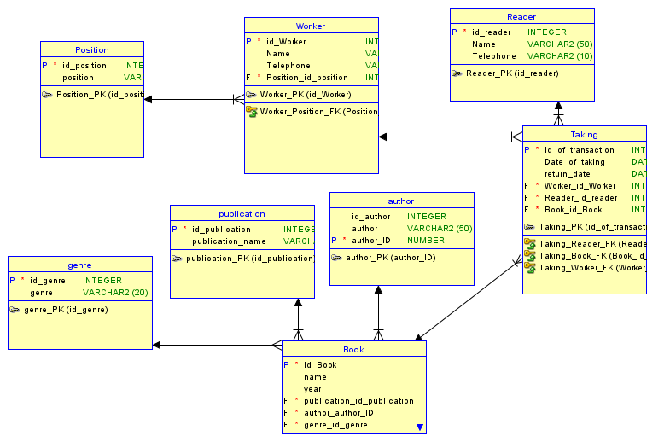

**Логически модел:**

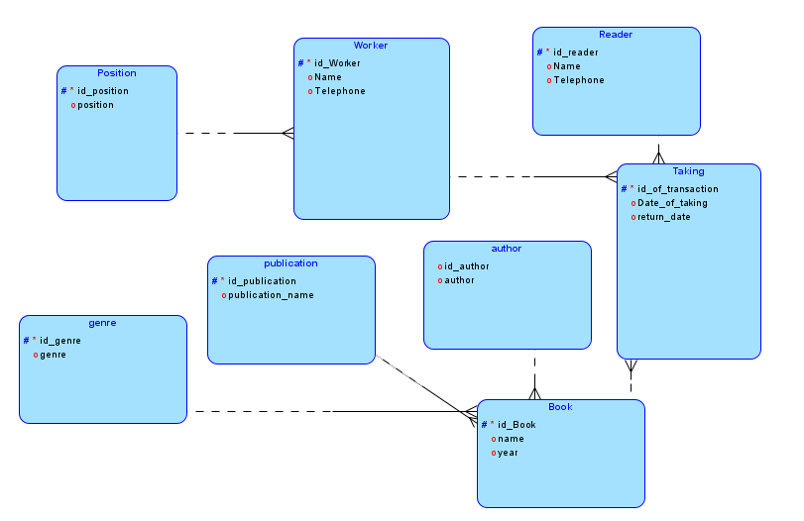

**Примерни данни:**

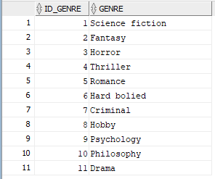  **АВТОР: ЖАНЪР:**

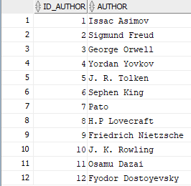

**КНИГА:**

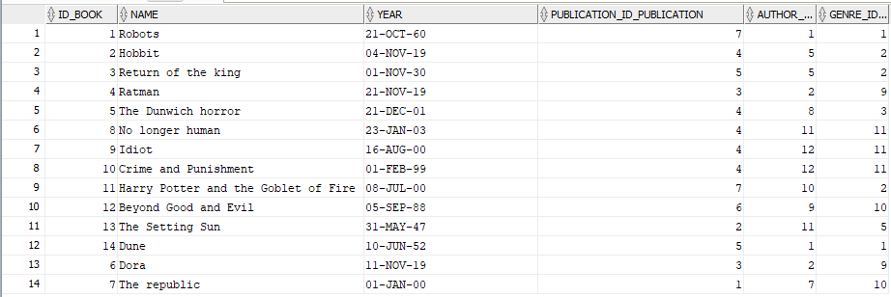

**ИЗДАТЕЛСТВО:**   **СЛУЖИТЕЛСКИ ПОЗИЦИИ:**

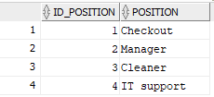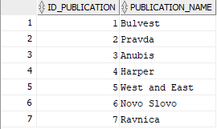

**ТРАНЗАНЦИЯ/ЗАЕМАНЕ:**

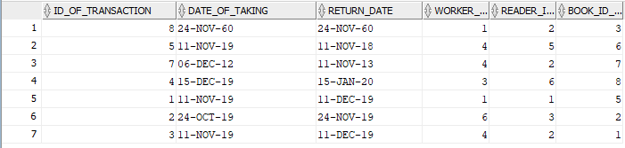

**ЧИТАТЕЛ/КЛИЕНТ:**

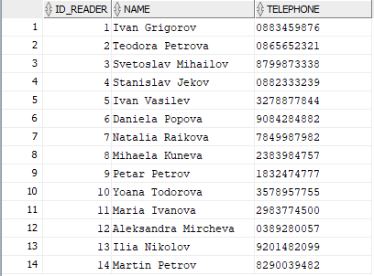

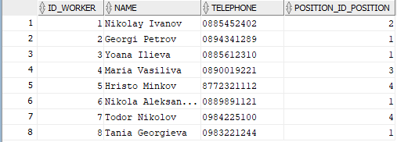**СЛУЖИТЕЛИ:**

**Код за генериране на таблиците:**

**-- Generated by Oracle SQL Developer Data Modeler 19.2.0.182.1216**

**-- at: 2019-10-21 08:41:33 PDT**

**-- site: Oracle Database 11g**

**-- type: Oracle Database 11g**

**CREATE TABLE author (**

**id_author INTEGER,**

**author VARCHAR2(50),**

**author_id NUMBER NOT NULL**

**);**

**ALTER TABLE author ADD CONSTRAINT author_pk PRIMARY KEY ( author_id );**

**CREATE TABLE book (**

**id_book INTEGER NOT NULL,**

**name VARCHAR2(50),**

**year DATE,**

**publication_id_publication INTEGER NOT NULL,**

**author_author_id NUMBER NOT NULL,**

**genre_id_genre INTEGER NOT NULL**

**);**

**ALTER TABLE book ADD CONSTRAINT book_pk PRIMARY KEY ( id_book );**

**CREATE TABLE genre (**

**id_genre INTEGER NOT NULL,**

**genre VARCHAR2(20)**

**);**

**ALTER TABLE genre ADD CONSTRAINT genre_pk PRIMARY KEY ( id_genre );**

**CREATE TABLE position (**

**id_position INTEGER NOT NULL,**

**position VARCHAR2(30)**

**);**

**ALTER TABLE position ADD CONSTRAINT position_pk PRIMARY KEY ( id_position );**

**CREATE TABLE publication (**

**id_publication INTEGER NOT NULL,**

**publication_name VARCHAR2(50)**

**);**

**ALTER TABLE publication ADD CONSTRAINT publication_pk PRIMARY KEY ( id_publication );**

**CREATE TABLE reader (**

**id_reader INTEGER NOT NULL,**

**name VARCHAR2(50),**

**telephone VARCHAR2(10)**

**);**

**ALTER TABLE reader ADD CONSTRAINT reader_pk PRIMARY KEY ( id_reader );**

**CREATE TABLE taking (**

**id_of_transaction INTEGER NOT NULL,**

**date_of_taking DATE,**

**return_date DATE,**

**worker_id_worker INTEGER NOT NULL,**

**reader_id_reader INTEGER NOT NULL,**

**book_id_book INTEGER NOT NULL**

**);**

**ALTER TABLE taking ADD CONSTRAINT taking_pk PRIMARY KEY ( id_of_transaction );**

**CREATE TABLE worker (**

**id_worker INTEGER NOT NULL,**

**name VARCHAR2(50),**

**telephone VARCHAR2(10),**

**position_id_position INTEGER NOT NULL**

**);**

**ALTER TABLE worker ADD CONSTRAINT worker_pk PRIMARY KEY ( id_worker );**

**ALTER TABLE book**

**ADD CONSTRAINT book_author_fk FOREIGN KEY ( author_author_id )**

**REFERENCES author ( author_id );**

**ALTER TABLE book**

**ADD CONSTRAINT book_genre_fk FOREIGN KEY ( genre_id_genre )**

**REFERENCES genre ( id_genre );**

**ALTER TABLE book**

**ADD CONSTRAINT book_publication_fk FOREIGN KEY ( publication_id_publication )**

**REFERENCES publication ( id_publication );**

**ALTER TABLE taking**

**ADD CONSTRAINT taking_book_fk FOREIGN KEY ( book_id_book )**

**REFERENCES book ( id_book );**

**ALTER TABLE taking**

**ADD CONSTRAINT taking_reader_fk FOREIGN KEY ( reader_id_reader )**

**REFERENCES reader ( id_reader );**

**ALTER TABLE taking**

**ADD CONSTRAINT taking_worker_fk FOREIGN KEY ( worker_id_worker )**

**REFERENCES worker ( id_worker );**

**ALTER TABLE worker**

**ADD CONSTRAINT worker_position_fk FOREIGN KEY ( position_id_position )**

**REFERENCES position ( id_position );**

**CREATE SEQUENCE author_author_id_seq START WITH 1 NOCACHE ORDER;**

**CREATE OR REPLACE TRIGGER author_author_id_trg BEFORE**

**INSERT ON author**

**FOR EACH ROW**

**WHEN ( new.author_id IS NULL )**

**BEGIN**

**:new.author_id := author_author_id_seq.nextval;**

**END;**

**/**

**КОМАНДИ ЗА ВЪВЕЖДАНЕ НА ДАННИ В ТАБЛИЦИТЕ:**

INSERT INTO book VALUES( bookseq.nextval, '&book_name' , '&book_date' , &book_publication_id ,&book_author_id ,&book_genre_id);

INSERT INTO reader VALUES(READERSEQ.nextval,'&reader_name','&reader_telephone');

INSERT INTO worker VALUES (WORKERSEQ.nextval, '&worker_name' , '&worker_telephone' , &worker_position);

INSERT INTO publication VALUES(PUBLICATIONSEQ.nextval, '&publication');

INSERT INTO position_ VALUES(POSITIONSEQ.nextval, '&position');

INSERT INTO genre VALUES(GENRESEQ.nextval, '&genre');

INSERT INTO author VALUES(AUTHORSEQ.nextval, '&author');

**КОМАНДИ ЗА КОРЕГИРАНЕ НА ДАННИ ОТ ТАБЛИЦИТЕ:**

UPDATE book SET name = '&name' WHERE id_book = &selected_id;

UPDATE reader SET name = '&name' WHERE id_reader = &selected_id;

UPDATE worker SET name = '&name' WHERE id_worker = &selected_id;

UPDATE publication SET publication_name = '&name' WHERE id_publication = &selected_id;

UPDATE author SET author = '&name' WHERE id_author = &selected_id;

UPDATE genre SET genre = '&genre' WHERE id_genre = &selected_id;

UPDATE position_ set position = '&position' WHERE id_position = &selected_id;

**КОМАНДИ ЗА :**

**Търсене на книга по ключова дума:**

SELECT BOOK.name , BOOK.year ,publication.publication_name ,AUTHOR.AUTHOR ,genre.genre FROM BOOK

INNER JOIN GENRE

ON book.genre_id_genre = genre.id_genre

INNER JOIN AUTHOR

ON book.AUTHOR_AUTHOR_ID = AUTHOR.id_author

INNER JOIN PUBLICATION

ON book.PUBLICATION_ID_PUBLICATION = publication.id_publication -- vsichko

WHERE BOOK.NAME LIKE '%&selected%';

При въведен “republic” на SQL изкарва “The republic”



**Търсене на книга по жанр:**

SELECT BOOK.name , BOOK.year ,publication.publication_name ,AUTHOR.AUTHOR ,genre.genre FROM BOOK

INNER JOIN GENRE

ON book.genre_id_genre = genre.id_genre

INNER JOIN AUTHOR

ON book.AUTHOR_AUTHOR_ID = AUTHOR.id_author

INNER JOIN PUBLICATION

ON book.PUBLICATION_ID_PUBLICATION = publication.id_publication

WHERE genre_id_genre = &Genre_ID;

****При въведено “1” (асоцийран с sci-fi жанра) SQL изкарва:

**Търсене на книга по автор:**

SELECT BOOK.name , BOOK.year ,publication.publication_name ,AUTHOR.AUTHOR ,genre.genre FROM BOOK

INNER JOIN GENRE

ON book.genre_id_genre = genre.id_genre

INNER JOIN AUTHOR

ON book.AUTHOR_AUTHOR_ID = AUTHOR.id_author

INNER JOIN PUBLICATION

ON book.PUBLICATION_ID_PUBLICATION = publication.id_publication

WHERE author_author_id = &Author_ID;

При въведенo “8” (асоцийран с автора H.P Lovecraft) SQL изкарва:



**Книги взети от читател:**

SELECT taking.book_id_book, book.name FROM taking

INNER JOIN book

ON taking.book_id_book = book.id_book

WHERE taking.reader_id_reader = &reader_ID;

При въведен “1” ” (асоцийран с първи чтател) SQL изкарва:



**Невърнати книги, подредени по дата:**

SELECT * FROM taking ORDER BY return_date;

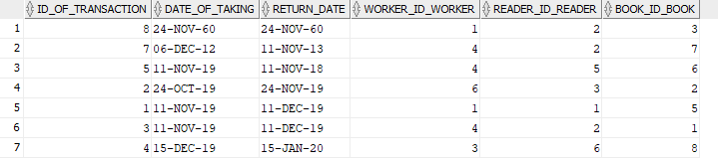

**ТРИГЕРИ:**

**Тригер за генериране на ID за нов работник:**

create or replace trigger WORKERTRIGGER

before insert on "HR"."WORKER"

for each row

begin

if inserting then

if :NEW."ID_WORKER" is null then

select WORKERSEQ.nextval into :NEW."ID_WORKER" from dual;

end if;

end if;

end;

**Тригер за генериране на ID за нов автор:**

create or replace trigger AuthorTrigger

before insert on "HR"."AUTHOR"

for each row

begin

if inserting then

if :NEW."ID_AUTHOR" is null then

select AUTHORSEQ.nextval into :NEW."ID_AUTHOR" from dual;

end if;

end if;

end;

**Тригер за генериране на ID за нов жанър:**

create or replace trigger genreTrigger

before insert on "HR"."GENRE"

for each row

begin

if inserting then

if :NEW."ID_GENRE" is null then

select GENRESEQ.nextval into :NEW."ID_GENRE" from dual;

end if;

end if;

end;

**Тригер за генериране на ID за нова позиция:**

create or replace trigger POSITIONTRIGGER

before insert on "HR"."POSITION_"

for each row

begin

if inserting then

if :NEW."ID_POSITION" is null then

select POSITIONSEQ.nextval into :NEW."ID_POSITION" from dual;

end if;

end if;

end;

**Тригер за генериране на ID за нова побликация:**

create or replace trigger PUBLICATIONSEQ

before insert on "HR"."PUBLICATION"

for each row

begin

if inserting then

if :NEW."ID_PUBLICATION" is null then

select POSITIONSEQ.nextval into :NEW."ID_PUBLICATION" from dual;

end if;

end if;

end;

**Тригер за генериране на ID за нов читател:**

create or replace trigger READERTRIGGER

before insert on "HR"."READER"

for each row

begin

if inserting then

if :NEW."ID_READER" is null then

select READERSEQ.nextval into :NEW."ID_READER" from dual;

end if;

end if;

end;

**Тригер за генериране на ID за ново заемане:**

create or replace trigger TAKINGTRIGGER

before insert on "HR"."TAKING"

for each row

begin

if inserting then

if :NEW."ID_OF_TRANSACTION" is null then

select TAKINGSEQ.nextval into :NEW."ID_OF_TRANSACTION" from dual;

end if;

end if;

end;

**Тригер за генериране на ID за нова книга:**

create or replace trigger newnwnewtrigger

before insert on "HR"."BOOK"

for each row

begin

if inserting then

if :NEW."ID_BOOK" is null then

select BOOKSEQ.nextval into :NEW."ID_BOOK" from dual;

end if;

end if;

end;

**Source code:**

ALTER TABLE taking ADD CONSTRAINT taking_bbq UNIQUE (book_id_book);

INSERT INTO book VALUES( bookseq.nextval, '&book_name' , '&book_date' ,&book_publication_id, & book_author_id, &book_genre_id);

INSERT INTO reader VALUES(READERSEQ.nextval,'&reader_name','&reader_telephone');

INSERT INTO worker VALUES (WORKERSEQ.nextval, '&worker_name', '&worker_telephone' ,&worker_position);

INSERT INTO publication VALUES(PUBLICATIONSEQ.nextval,'&publication');

INSERT INTO position_ VALUES(POSITIONSEQ.nextval,'&position');

INSERT INTO genre VALUES(GENRESEQ.nextval,'&genre');

INSERT INTO author VALUES(AUTHORSEQ.nextval,'&author');

INSERT INTO taking VALUES( &transation_id, '&taking_date' , '&return_date' ,&worker_id,&reader_id,&book_idf);

UPDATE book SET name = '&name' WHERE id_book = &selected_id;

UPDATE reader SET name = '&name' WHERE id_reader = &selected_id;

UPDATE worker SET name = '&name' WHERE id_worker = &selected_id;

UPDATE publication SET publication_name = '&name' WHERE id_publication = &selected_id;

UPDATE author SET author = '&name' WHERE id_author = &selected_id;

UPDATE genre SET genre = '&genre' WHERE id_genre = &selected_id;

UPDATE position_ set position = '&position' WHERE id_position = &selected_id;

SELECT BOOK.name , BOOK.year ,publication.publication_name ,AUTHOR.AUTHOR ,genre.genre FROM BOOK

INNER JOIN GENRE

ON book.genre_id_genre = genre.id_genre

INNER JOIN AUTHOR

ON book.AUTHOR_AUTHOR_ID = AUTHOR.id_author

INNER JOIN PUBLICATION

ON book.PUBLICATION_ID_PUBLICATION = publication.id_publication

WHERE BOOK.NAME LIKE '%&selected%';

SELECT BOOK.name , BOOK.year ,publication.publication_name ,AUTHOR.AUTHOR ,genre.genre FROM BOOK

INNER JOIN GENRE

ON book.genre_id_genre = genre.id_genre

INNER JOIN AUTHOR

ON book.AUTHOR_AUTHOR_ID = AUTHOR.id_author

INNER JOIN PUBLICATION

ON book.PUBLICATION_ID_PUBLICATION = publication.id_publication

WHERE genre_id_genre = &Genre_ID;

SELECT BOOK.name , BOOK.year ,publication.publication_name ,AUTHOR.AUTHOR ,genre.genre FROM BOOK

INNER JOIN GENRE

ON book.genre_id_genre = genre.id_genre

INNER JOIN AUTHOR

ON book.AUTHOR_AUTHOR_ID = AUTHOR.id_author

INNER JOIN PUBLICATION

ON book.PUBLICATION_ID_PUBLICATION = publication.id_publication

WHERE author_author_id = &Author_ID;

SELECT taking.book_id_book, book.name FROM taking

INNER JOIN book

ON taking.book_id_book = book.id_book

WHERE taking.reader_id_reader = &reader_ID;

SELECT * FROM taking ORDER BY return_date;